FIFA WORLD CUP

The FIFA World Cup is an international football tournament organized by the Fédération Internationale de Football Association (FIFA). It features teams from around the world competing for the title of world champion. Held every four years, it is one of the most prestigious and widely viewed sporting events globally.



**About this project**

**Introduction:**

This project involves extracting, profiling, and analysing FIFA World Cup data . The primary focus is on creating a comprehensive report that includes key information such as the year, host country, champion, runner-up, final score, and the number of participating teams. The project aims to provide insightful visualizations for better understanding and interpretation of the data.

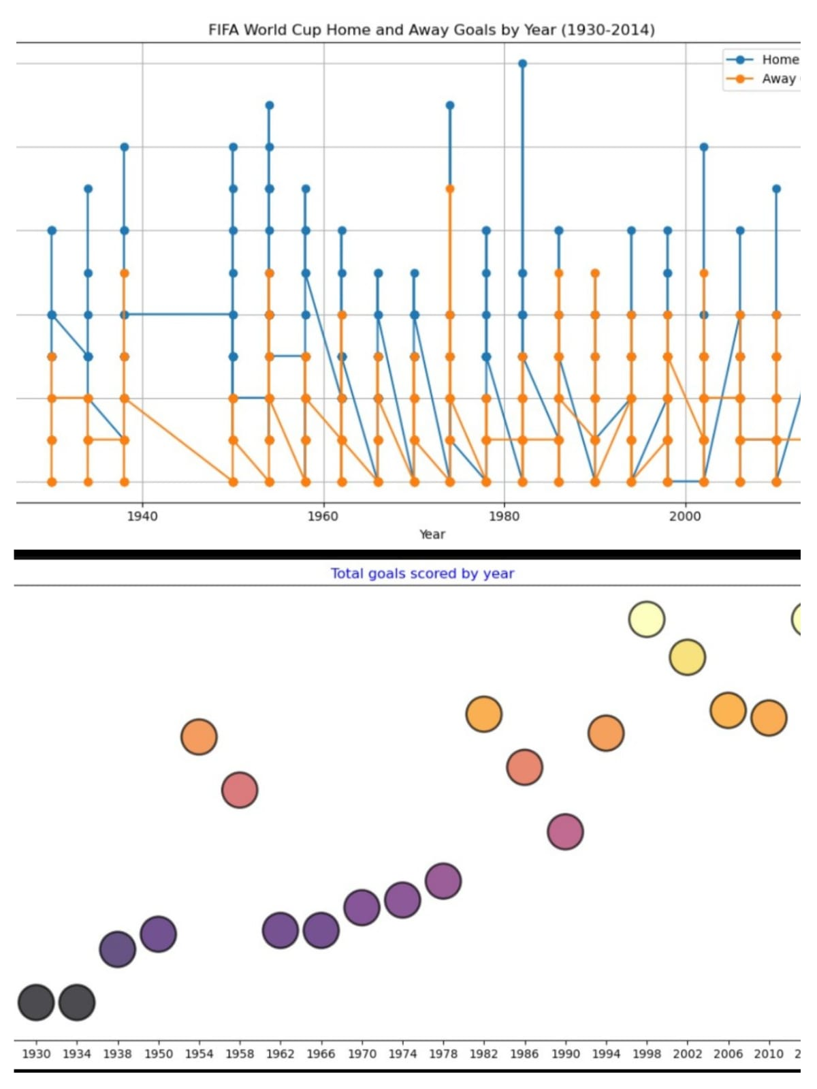

Purpose:

Analyzing FIFA World Cup data helps teams evaluate performance, devise tactical strategies, and identify player talent. It enhances fan engagement by offering interesting statistics and historical comparisons. Businesses can leverage insights for marketing opportunities, while academics can conduct research on various aspects of the tournament. In summary, analyzing FIFA World Cup data serves to improve team performance, engage fans, drive business decisions, and advance academic knowledge.

Dataset:

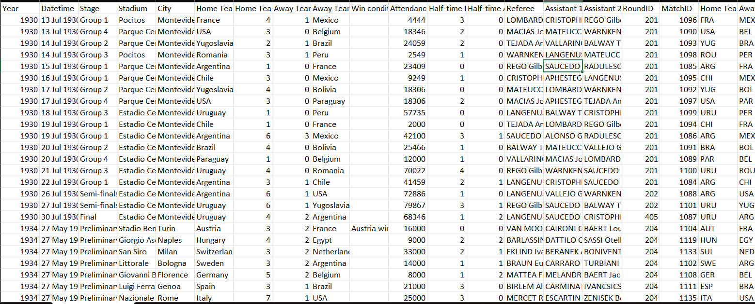

Objectives:

* To get useful insights from the FIFA WORLD CUP dataset and visualize to give some interesting figures to the football fans.
* This project is based on FIFA World Cup Analysis to get insights about players , Pattern about cup holders, Home Ground Advantage and many more things.

**Benefits:**

* Most number of world cup winning title
* Number of goal per country
* Attendance, Number of Teams ,Goals and Matches per cup
* Goal Per Team per world cup
* Matches with highest number of attendance
* Stadium with highest average attendance
* Which countries had won the cup?
* Number of goal per country
* Matches Outcome by home and away teams

**Additional Images:**

